Style Guide for Submitting Papers to
9th International Conference on
Malaysia-Indonesia Relations (PAHMI 9)
Faculty Of Social Sciences
Yogyakarta State University, 15-16 September 2015

(Each Word of the Title Should be Capitalised and Not More Than 10 Words)

Name Surname 1
Institute/Company
e-mail address
Name Surname 2
Institute/Company
e-mail address

ABSTRACT
This file provides a template for writing papers for the conference. The full paper in MS Word file shall be written in compliance with these instructions. Later on it will be converted into Portable Document Format (PDF).
Write an abstract of maximum 300 words including: background, objectives, methods used, research results and impacts of your study. The abstract should not be a table of contents in prose, neither should it be an introduction. It should be informative. Tell the reader what the research was about, how it was undertaken and what was discovered, but not how the paper is organized. The main findings must be summarized.

Keywords: (5 short keywords max.)

Theme: (Should address primary symposium theme)

INTRODUCTION
It is expected that authors will submit carefully written and proofread material. Spelling and grammatical errors, as well as language usage problems, are not acceptable. There is no strict limitation to the number of pages, but it is suggested that the paper length should not exceed 15 pages.
Papers should clearly describe the background of the subject, the authors work, including the methods used, and concluding discussion on the importance of the work. Papers are to be prepared in English.

paper format
The uniform outlook will help the reader to follow the proceedings. This can be obtained most easily if authors use this template file to construct their papers. Please note the following details: this template is an A4 format with 20 mm margins left, right, top and bottom. Header and footer shall be positioned 16 mm from the edge.
All text paragraphs should be single spaced, with first line indented by 10 mm. Double spacing should only be used before and after headings and subheadings as shown in this example. Position and style of headings and subheadings should follow this example. No spaces should be placed between paragraphs. Please DO NOT change any of the above mentioned page, paragraph and font settings.

Header, Footer, Page Numbering
If this template is used when writing the full paper, headers will be set automatically.

Fonts
Papers should use 12-point Times New Roman font. The styles available are bold, italic and underlined.
It is recommended that text in figures is not smaller than 10-point font size.

Tables and Figures
Figure captions and table headings should be sufficient to explain the figure or table without needing to refer to the text. Figures and tables not cited in the text should not be presented. Styles Heading Table and Caption Figure are available in this template for tables and figures.

The following is the example for Table 1.
Table 1 Title of Example Table
Table | Table | Table | Table
Table | table | table | table
Table | table | table | table

Tables and figures should be placed close after their first reference in the text. All figures and tables should be numbered with Arabic numerals. Table headings should be centred above the tables. Figure captions should be centred below the figures.

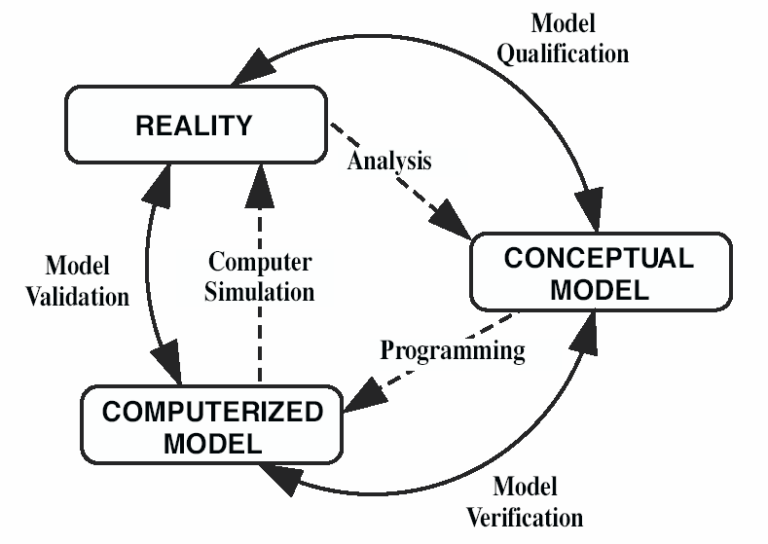
Figure 1: Verification, Validation and Qualification

Equations
Each equation should be presented on a separate line from the text with a blank space above and below. Equations should be clear and expressions used should be explained in the text. The equations should be numbered consecutively at the outer right margin, as shown in Eq. (1) and (2) below. Here is one example. The number of different ways that a specified component can fail with (k-1) other components in a group of m similar components is:

(1)

Thus, the total failure probability, Q_{t}, of component in a common cause group of m components is:

(2)

SUBMITTING THE Paper
The draft version of the full paper has to be submitted electronically by e-mail to the address malindo.conference@gmail.com. Final version of the paper and abstract should be submitted by 5th June, 2015 (Friday).

Conference Programme and proceedings
The abstracts and final papers are compiled into the Conference Proceedings.

conclusion
Conclusions should state concisely the most important propositions of the paper as well as the author’s views of the practical implications of the results. The length of each paper for presentation should not exceed 4,000 words (approx. 8 pages-single spaced including endnotes and references referred to (Cited references) with the APA style.

REFERENCES
Battikha, Mireille G. and Colin H. Davidson (1996) “Cause and Effect 3-D Model for measuring performance in Construction Acceleration: a Decision Support System” Building Research and Information, Vol. 24, No 6, pp.351-357.

Davidson, Colin H. (ed) (1998) Information in the Building Industry – Problems and Solutions, Montréal, IF Research Corporation, (electronic book on the Internet).

Phillips, E. Barbara (1996) City Lights: Urban and Suburban Life in the Global Society. Oxford University Press; New York.

